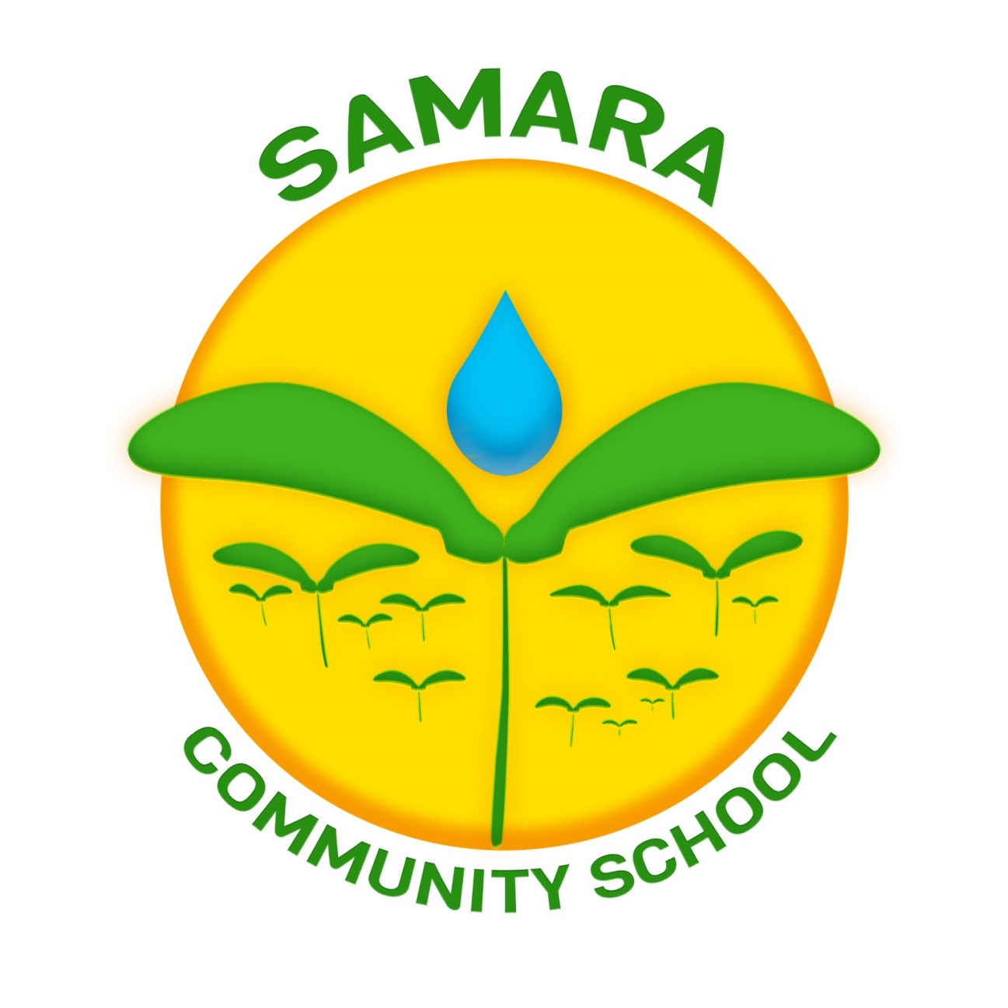Parent Handbook 2018-2019

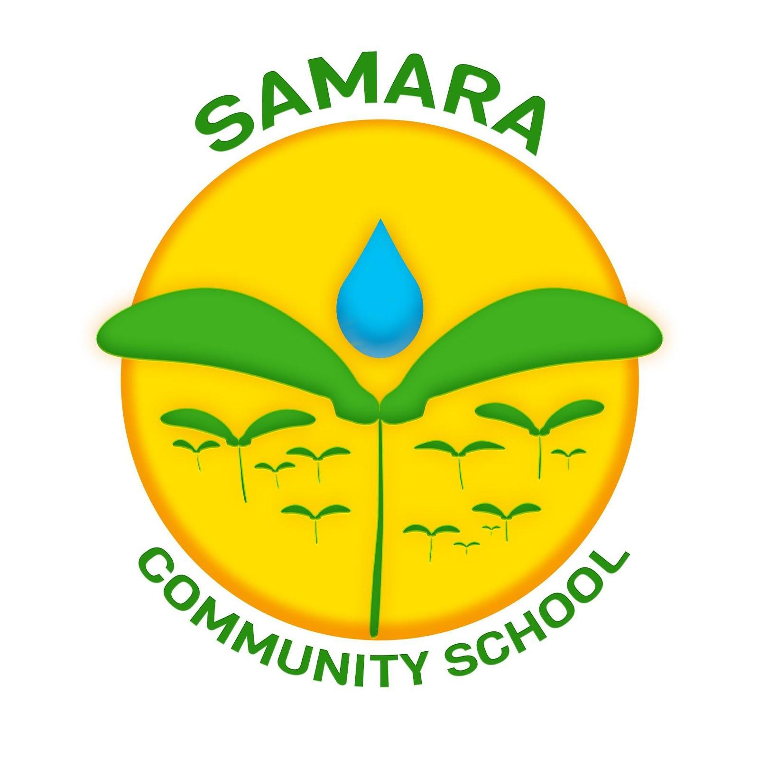

August 2018

Dear Samara Community School Family,

We are delighted to welcome you to a wonderful school community. We know it will be a place full of learning, fun, new beginnings, exploration, and language. We thank you for taking part in this voyage with us.

We want you to know that we feel that a strong family connection is essential to our children’s success. We want you to be involved in every step of the way. We would love to see you helping out in the school, on field trips and communicating in the family communication notebooks. We want to hear your opinions and ideas. We value your ideas and thoughts. In this handbook, you will find more information about many of the ways to get involved.

This handbook also serves to provide information regarding school operations and things parents most frequently ask about. Use the table of contents as your guide to find your answer to your question. If you cannot find an answer to your question, please feel free to ask! We are here to serve you!

We look forward to working with you for the advancement of your child, academically, socially and emotionally.

In solidarity,
Samara Community School

Table of Contents
Academics
Curriculum
Homework and Book Baggies
Field trips
Report cards and progress reports
Dual language
Swimming/Capoeira/Tennis
4-day schedule rotation
Supply list
Photographs

Ways to be involved
Sing-Along Mondays
Family events
First few days of school (orientation)
Parent Association
School Leadership Team
Class Parent and Facebook page

Basic Information
Co-Located Schools
**Arrival
Dismissal
Uniforms
Attendance
**Lunch and Lunch Forms
Naps
Early pick-up
Late pick-up
After-School Options
Extended vacation
Sign-In
Samara Community School’s Growth
Parent Report Card
Swimming Policy
Recess
Physical Education
Snack Policy
Lost and Found
Cell phone policy
Allergies
Celebrating Birthdays
Family Practices
Lending Library
Family Book

Communicating with the School
School letters
Issues/concerns/ideas
Communicating with teachers
Parent Communication Notebook
Updating biographical information
Newsletter
Facebook/Twitter

Basic Information
Co-Located Schools
Samara Community School shares the Clara Barton School Campus with Fairmont Neighborhood School (PS314). We share common spaces; however, all principals have worked diligently to ensure that all children do not come in contact, unless otherwise planned. Our school utilizes the second floor for our classrooms. The cafeteria and recess time has been scheduled for our use exclusively. PS314 has done the same to ensure the separation of both schools. We also work together to make sure all space usage and concerns are addressed in a way that is fair to all schools with the safety and well-being of all of our children in mind.

Arrival
All children arrive for breakfast at 7:45 through the side cafeteria entrance on Vyse Avenue. Children have the option to eat breakfast or to wait for their teacher. Pre-kindergartners will eat breakfast in their classrooms. Only pre-kindergarten parents are allowed to bring their students to the classroom. Other than that, parents are not allowed past the security desk. If you have an issue or concern, see that section for more information. The official day begins at 8:00. Any child that arrives after that time will be marked late. If your child is late, he/she will go to the office and get a late pass to class if it is after 8:00.

Dismissal
Children are dismissed from the left side of the yard on Bryant Avenue at 2:20 every day. In the case of inclement weather, parents will pick up their children from same side of Bryant Avenue, however, in the North Yard. Parents should ONLY enter through the Bryant Avenue entrance to pick up their children. Only people that are listed on the blue card will have access to pick up your child. If you need another person not on the blue card to pick up your child, please send in a note with the child in the morning in the Parent Communication Notebook, giving that person permission. Children will not be given to someone who is not on the blue card.

Uniforms
We are a uniform school. Our children wear navy or white polo or button-down shirts with our school logo with khaki bottoms (skirt, pants, jumper). You can purchase uniforms at http://samara.nycschooluniforms.com. Please let us know if we can help ensure your child has a uniform daily. We will also inform you in advance if we have a special non-uniform day. This is our uniform:
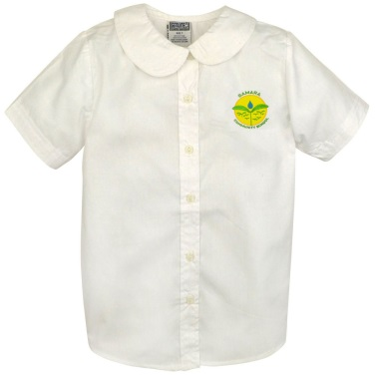

Attendance
It is imperative that your child is present daily. If your child misses a day of school, he or she has to make up any lost assignments. This is an interruption for children and affects their learning. Unless your child has a medical excuse, children should be here daily. Please make sure to bring documentation to the office.

Lunch and Lunch Forms
We eat lunch family style in pre-kindergarten and children in kindergarten and on eat in the cafeteria. Children set the tables and eat with one another to promote socialization. Please make sure that if you bring your child’s lunch that it is healthy. Lunch is an important part of the day to refuel our children and get them ready for the second half of the day. Please help them refuel properly. Even if your child will be bringing his or her own lunch, you must complete the lunch form before school starts or your child will be charged full price. This year all students must apply for lunch on the website: https://www.applyforlunch.com/ to complete the application. Please come to the office if you need support.

Naps
In pre-kindergarten, our students take a nap on a daily basis. We understand that some children do not like to take naps and we will work with your child to accommodate his or her needs. Children are required to have their own bedding. This should include a blanket, sheets and maybe a favorite teddy. Families will take the child’s bedding home on a weekly basis for cleaning and return it on Monday.

Early pick-up
We strongly discourage picking up your child early from school, as it is an interruption of your child’s learning and the class. Please make appointments for your child after school hours, if possible.

Late pick-up
Please ensure that you pick your child up on time. We do not have the available staff to take care of children during after school hours. If your child has not been picked up and we cannot get a hold of you, we will take your child to the police precinct where you will have to pick your child up. Please communicate with the school if you are having difficulty picking your child up. If this is a repeated occurrence, please consider our after-school options.

After-School Options
We have two after-school options for families who need their child to be enrolled in an after-school program. Children who are five and older are able to enroll in the Children’s Aid Society after-school program which picks their children up after school and dismisses at 5:30. You may contact the program at: 347-821-4233 or visit the office in room 302. They are located in our building. Madison Square Boys and Girls Club around the corner on Hoe Avenue is also an option for children and they have a pick-up service. Pre-kindergarten does not have an after-school option, however, there are day care options in the neighborhood.

Extended Vacation
The NYCDOE sets specific vacation days for families and staff well in advance to support those needing to travel. Please plan your vacation travel during official school vacation days and stick to these days when planning your vacation. It is imperative that all children are present every official school day. Instruction happens right up until the last day of vacation and this means that learning is still going on. For reference on vacation days you can access the calendar online at schools.nyc.gov/calendar.

Sign-In
To ensure the safety of all adults and children, all families are required to sign in at the front desk and get a pass before coming to the main office. You must come to the main office before arriving at your final destination.

Samara Community School’s Growth
2016-2017: Pre-Kindergarten-Second Grade
2017-2018: Pre-Kindergarten-Third Grade
2018-2019: Pre-Kindergarten-Fourth Grade
2019-2020: Pre-Kindergarten-Fifth Grade

Parent Report Card
Samara Community School holds all parents accountable as we do for our children. As you know, a parent’s support is extremely important in the success of their child. Please see the parent report card in the appendix. We will be giving you a report card in November and March alongside your child’s report card. We will be measuring attendance and punctuality, uniforms, parent communication and parent participation. Parent honor roll ceremonies will occur in June to celebrate parents who have a 3 on the report card.

Swimming Policy
We swim at the Madison Square Boys and Girls Club in the Spring. During the swimming season, all students should come prepared ready for swimming. Please note that sometimes students get nervous and don’t want to swim. We have many ways to support these students so please ensure that your child attends their scheduled day and time.

Recess
Children benefit from vigorous exercise and should be given the opportunity to play outside whenever possible. Unless it is snowing, there is ice on the playground, or the wind chill factor creates an effective temperature below zero degrees Fahrenheit (-18 degrees Celsius), temperature alone should not be a barrier to outdoor play. We will be following these guidelines for outdoor play. We ask that all families dress their children for outdoor play EVERY DAY. This includes winter coats and other items to keep children’s heads and extremities warm. We will be working to ensure that students cover exposed skin, wear warm clothing and use multiple layers of clothing to maintain warmth. If the weather does not permit for outdoor play, students will play for 20 minutes by grade in the North Yard in lieu of outdoor recess during their regular lunch periods.

Snack Policy
New this year, we are asking parents for donations for snacks in the classroom. We ask that parents bring snacks for the entire class, (this is also one way to be involved at school). We will not be collecting funds, so we are asking for various types of healthy treats. Please see the campus snack policy in the appendix.

Lost and Found
If you are missing an article of clothing, please check our lost and found in the main office. Please also ensure that all of your articles of clothing, including backpacks, hats, gloves, jackets and sweaters, are clearly labeled with your child’s name.

Cell Phone Policy
Please see the cell phone policy in the appendix. This must be signed and returned to school in the first week.

Allergies
If your child has an allergy to any type of food or something that the school should know, please inform us immediately so we can make the necessary arrangements.

Family Practices
Please let us know if you do not celebrate any particular holiday or festivity so that we can ensure that we respect all family practices and religions to the best of our ability.

Celebrating Birthdays
We know that many families want to celebrate birthdays during the school day. To minimize interruption to instruction, we are allowing families to celebrate a child’s birthday with cupcakes, juice and refreshments at 2:10 in the afternoon. We ask that you notify us with a week in advance. Please remember we do not allow our children to drink soda in school.

Lending Library
We have a wonderful lending, bilingual library in the office that all parents are more than welcome to utilize to take out books to read at home. Please visit the library in the office. We have replenished it with new books as well.

Family Book
At the beginning of the year, we will be giving all families a blank hardcover book. This is your first family homework assignment where you are asked to fill the pages of the book with pictures of your child and their family and share with the other students all about your family. This book will live in the classroom for other students to read and for your child should he or she feel sad and want to see you during the school day. Please return this by September 21. This book will remain with your child for his/her school days and will eventually be returned.

Communicating with the School
School Attendance letters
If you need a school attendance letter, please come to the office to complete a letter request form. We will provide the letter within 24 hours.

Issues/concerns/ideas
If you have an issue, concern or idea, we want to hear from you. You can come to the main office and complete a parent intake form and we will get back to you within 24 hours. You may also email your idea/concern/issue to: info@samaracommunityschool.org. If you have an immediate concern, please set up an appointment. We will do our best to meet your needs as soon as possible.

Communicating with Teachers
If you need to discuss something with a teacher, you can also utilize the Parent Communication Notebook to get a response by the next morning. See more information in the next section regarding the parent communication notebook. If you need to speak to a teacher immediately, call the office and set up an appointment or speak to the teacher at dismissal.

Parent Communication Notebook
The Parent Communication Notebook is the perfect place for you to find out what your child is up to on a weekly basis and also address/document any concerns you might have. Teachers will send you a picture with a caption on something your child has been doing throughout the week to give you a sense of what is going on in the classroom. We also want to hear from you and expect that once a week you tell us something that you are noticing, maybe while your child is reading, or maybe you tell us about something you did during the weekend that we might use to spark a conversation or give possible ideas during story time. This is one way we can build a stronger bond with our families.

Updating Biographical Information
Any time that you have a change in your address, phone number or any other biographical information, please notify the office so that we can update your records. It is important to have the most up-to-date information in case we need to get in touch with you during the day and also to ensure that you receive all school notifications.

Weekly Newsletters
Look in your child’s backpack on Fridays. This is where you will find the weekly newsletter, highlighting the upcoming weekly events, exciting moments from the classroom and suggestions for weekend outings. In an effort to save paper, you will not receive many other communications other than this newsletter. It is important to review it in its entirety as it contains updated information for the upcoming week.

Facebook/Twitter
We are trying to get with the times and therefore, we are on Facebook as “Samara Community School” and Twitter at “Samaracommunity”. “Like” our school page and you will also receive notifications of upcoming events and information as well as connect with our school community. Furthermore, ensure that your child has a media consent form on file. If you do not wish for your child to appear on the page, please let the office staff know. Otherwise, every year we ask that you sign a media consent form for us to upload pictures to our page.

Academics
Dual language
Our children learn in Spanish and English. Each day, your child rotates between Spanish and English. Your child has a Spanish teacher and an English teacher so that he or she knows exactly what language he or she should be speaking that day. The master calendar will also help you as a parent know what day it is so that you can prepare your child. We understand that learning a new language can be difficult, and we want to ensure that your child is supported every step of the way. We make learning a new language fun and as we say- comprehensible. You will have an opportunity during the school year to attend a class in your second language and see how we make it fun so you understand what is going on. (You might even want to stay longer :)).

Curriculum
Reading: Every child varies developing early reading skills. As a result, we spend a lot of time in small groups working with children on their level. For some children, this means they are reading books while others are just learning how to find beginning sounds in a word. We also use a program called the Kindergarten Literature program in Pre-Kindergarten and Kindergarten where children and the teacher read fun, wordy books repeatedly over a week so that the children begin to memorize the storyline and can essentially “read” the book themselves, and act it out as well. We also use song as a way to build early literacy skills and build language. Our integrated studies are another time for children to read more about different subjects in the context of what they are learning.

Phonics: We use a Linguistic Phonics approach. Linguistic Phonics is an approach to reading and spelling that builds on speech. Children begin by listening to words that they say everyday: noticing syllables, rhyme and eventually individual sounds. They then learn how these sounds are represented by letters through investigation, ‘cracking the code’ through problem-solving. Children are very good at ‘working things out’ if they are presented in the right way at the right time! It is very important not to rush your child or to expect him to know things before he is ready!
The best way to help at home is to:
- have plenty of conversations to increase your child’s vocabulary - the more words he can say, the more words he will eventually be able to read and write!
- play lots of word games – there are lots of ideas below
- read to your child as much as possible – stories, information books, poems, instructions, time-tables, magazines etc.
- show that you enjoy reading and writing
- have fun helping your child learn

Writing: We have different writing units throughout the year where children learn different types of writing and the features within each genre. They learn to think like writers and develop their own stories. They will publish pieces of writing in both languages throughout the year and we will invite you to come to our publishing ceremonies to celebrate their writing. These units are all aligned to our integrated studies work.

Integrated Studies: In kindergarten, students are immersed in a year-long study of the maple tree and a unit on animal families and their own family. In first grade, students study water and think about the idea of where their water comes from in an in-depth study. Through these studies, students learn through reading, writing, math, science and inquiry work. We take trips to different cultural institutions and around the community to deepen our thinking. We will invite you in at different points, to share in our learning and to use your expertise. We look forward to partnering with you, especially during these studies.

Math: We use a program called Engage NY. Our goal is to promote mathematical thinking and therefore, students ponder various mathematical questions and engage in rich discussion around the topic. We also support our children’s ability to think deeply about math through word problems, which are also a way to challenge them to work together to solve a problem.

Science: Our science units are integrated with the arts and investigations. We use the FOSS science kits to support our investigations and have planned many different connections with the arts, including visual arts, drama, dance and music. Our three units in Kindergarten include: trees in the fall, animals in the winter and a return to trees in the spring. We will also take field trips to deepen our thinking in each of the units. In first grade, students think about water and the states of matter, animal dependence on water and the water cycle through seasons and weather.
The Arts: The Arts, including, music, dance, visual arts and drama are woven throughout the curriculum. For instance, your child will sing every day, especially during our Sing-Along Mondays (see ways to get involved). Students take music and art classes throughout the week.

Homework and Book Baggies
We consider homework to be a time where children are able to reinforce the basic skills they have been learning in school. In kindergarten and on, children will be asked to read independently and with an adult nightly, practice sight word lists and practice math skills. Your child will receive a book baggie weekly with new and some known books. Please read all of the books and ensure that they are ALL returned into your child’s book bag nightly. From time to time there might be other assignments and you will be notified in the homework weekly sheet that goes home with your child at the beginning of the week.

Field trips
Field trips are a regular part of the curriculum. We will ask that you sign a walking permission slip for the year so that your child may be allowed to take a walking trip around the neighborhood as part of their studies. Students will take trips every other week. Please see the calendar for more information. We will announce these trips in advance. We will also ask that you sign any other trip permission slips you receive in a timely fashion. We encourage parents to attend all field trips, unless we have limited space. Please let us know if you would like to join us.

Report cards and progress reports
We believe it is essential that families get the whole picture of how their child is progressing in school. Therefore, we write anecdotal reports of your child twice a year (November and June) so that you get the bigger picture of your child’s progress. During three other times throughout the year, you will receive a progress report, detailing how your child is progressing based on the Common Core Standards. We encourage families to get involved, ask questions and understand what the reports mean. Please feel free to reach out to us for more information.

Physical Education
Students participate in physical education classes with the gym teacher on Wednesdays. On other days, teachers provide 30 minutes of physical activity in their classrooms. Teachers take energizer breaks where they dance, do jumping jacks, or other types of breaks. Teachers also take their classes down to the North Yard for physical play when it is not in use, and do Mighty Milers in the spring (all parents are invited to walk with their class- more information to follow).

Swimming/Capoeira/Tennis
We have chosen three sports in our community that we feel support our children in becoming well-rounded, healthy individuals. Maybe someday one of our children will make it to the Olympics and will be able to cite our program as the start of something great. In the fall, we play tennis at the Cary Leeds Center in Crotona Park. We will be walking to the classes. The center offers free and reduced rates for community members and it is our hope that if your child enjoys tennis, that you pursue it outside of school. Please wear the gym uniform for these days. We will notify you of the schedule.
During the winter months, we will be doing capoeira. On this day, please make sure that your child wears sweatpants and a t-shirt so he or she may move freely. We will notify you of your scheduled day of the week. This is a physical activity.

In the Spring, we swim. Swimming is an excellent form of exercise and is so much fun. As a result, our children participate in a ten-session program with the Madison Square Boys and Girls Club starting in Kindergarten. They swim one day a week in a one-to-seven ratio. The staff is very experienced and our teachers are right alongside the students. Please let us know if you have any questions or concerns. We promise you will see some pictures when we begin to ease any concerns you might have.

4-day rotation
We have many days off throughout the year and many of them happen to fall on a Monday. For these reasons we operate on a four-day rotation instead of on a Monday-Friday schedule. This means that we have an A day, B day, C day and D day. Then, we repeat this all over again. Look on the calendar to see what day it is. This will also help you understand whether it is a Spanish or English day for your child.

Calendar
You will receive a monthly calendar with all of the important events and notifications. On a weekly basis, you will also receive a newsletter with the upcoming events for the following week. We have done our best to inform you about all events with as much advance notice as possible. For any last minute updates, we will notify you via flyer or phone or through a Facebook and email blast.

Supply list
Attached to this family handbook, you will find the supply list. Please note that we take all supplies and put them in our closets for communal use. This means that if anyone needs a pencil, we will provide him or her with a pencil from the communal pencils. By purchasing the supplies, you are helping us ensure that our classrooms are well supplied and run smoothly.

Photographs
We take many pictures throughout the day to document the work we are doing with our students. You will also receive some of these or view them on our bulletin boards. In addition, there are times when the Department of Education and visitors may request to take pictures. We will advise you of this well in advance and you are always available to opt-out even after signing the photographing waiver. Please make sure you do sign it, however, so that we may take photographs.

Ways to be involved
Sing-Along Mondays
This is a great time to spend a Monday morning singing with our students and starting the week off in a great way. From 8:00 to 8:25 on Monday mornings, we will sing as a school from our school songbooks. We encourage you to join in our sing-along and learn all of the wonderful songs your children are learning.

Family events
We have put together a varied line up of family events for our families. We want to showcase all of the wonderful things your child accomplishes during times of the year and, share in the magic of science, math reading, art and so much more. We strongly encourage you to attend. You will learn how to help your child at home, view the accomplishments of your child, and get to know other parents. Please note the dates in the calendar.

First few days of school (orientation)
We will host a Pre-Kindergarten and Kindergarten orientation on Tuesday, September 4 at 5PM. Parents should bring their children so that they can meet their teacher and spend an hour in their classroom before the big day. While their children are in their classrooms, families will meet with the principal to get more information about the first few days of school and what to expect. This will also be the time to have all of your questions answered.

Parent Association
Elections are usually held in May for the upcoming year. Our Parent Association executive board includes the roles of the President, Secretary and Treasurer. We will notify you at least 10 days before the first meeting at which we will elect our Parent Association Executive Board. We will also send you home a reminder. Please make every effort to attend this meeting. We want and need a strong parent voice in our school community.

School Leadership Team
School Leadership Teams (SLT) is school-based organizations in every school composed of an equal number of parents and staff. They meet at least once a month, determine the structure for school-based planning and share decision-making about important school policies. If you would like to be a part of the SLT, please let the Parent Association President or principal know. We would love to have your voice as part of our team. We will be holding elections in early September for the positions.

Class Parent
New this year, we will be asking for a class parent from each class. This position reports to our PA. This parent will rally other parents and reach out to invite them to volunteer and support classroom activities through a private class page on Facebook. If you are interested, please let us know! We would love to have you!

Campus-wide Healthy Snacks Policy
Our Vision
The Fairmont/Samara campus promotes smart choices when it comes to food and drinks so that our students have a healthy learning environment to grow and learn. Research shows that what we eat has a big influence on our health. Eating healthy fuels our students’ bodies and minds so they can remain focused in the classroom. It is important to establish healthy eating habits now to promote a healthy future. That’s why we are introducing a Healthy Snack Policy!
Fairmont/Samara Policy
A full healthy lunch, as well as fruit and/or other snack alternatives are offered during the school day at no cost to our students by the DOE. For students who choose to bring their own snacks, we advise packing foods and drinks that are low in add sugar, sodium, and fat. Packed snacks from home must meet the requirements of our healthy food policy. Listed below are examples of approved snacks and drinks. This policy will take effect 04/01/2017.
Please Note:
To implement the policy, staff will take away snacks that are on the Not Allowed Items list and provide students with an alternative healthy snack instead. The snack will be sent home with a note as a reminder of our healthy snack policy.
Approved Snacks
These foods should be your first choice. They provide lots of nutrients for our bodies. All fruits and vegetables in their raw, natural state are foods you should be eating every day.
Healthier Food Options | Healthier Drink Options
Fresh fruit | Low-fat or skim (fat free) milk
Granola bars or granola | Tap water (add fruit slices for flavor and fun)
Pretzels | Seltzer water with a little 100% fruit juice
Plain graham crackers  Fresh vegetables | 100% fruit juice (6oz recommended limit; such as  Juicy Juice, Apple & Eve, Natural Fruit Juices)
Baked chips | Unsweetened almond or soy milk
Trail mix
Rice crackers
Hummus
Whole wheat crackers
Applesauce
Dried fruit
Cheese
Yogurt without fruit topping

Snacks NOT permitted in school
These foods have a lot of added sugar, salt, and fat. They do not provide nutrients or lasting energy for best performance at school. They should be consumed once a week or less.
Food items NOT allowed | Drinks NOT allowed
Items with fructose, maltose, sucrose or sugar as one of their first ingredients | Chocolate milk
Juices with added sugar or high fructose corn syrup | Gatorade
Fried food (Ex: McDonald’s or KFC) | Soda (including ginger ale)
Chips (Ex: Doritos, potato chips) | Fruit juice that’s not 100% juice
Fruit snacks with high fructose corn syrup | Sweet teas
100 Calorie Packs (the brand) | Vitamin Water
Cookies/cake/pastries | All energy drinks
Snacks made with chocolate | Sunny D
 | Hot chocolate

*For additional ideas visit http://www.schoolfoodnyc.org/schoolfoodny/resources/snackandbeverageguidelines.pdf
Questions?
If you have questions about this snack policy or what is or is not permitted to pack for your student, please reach out to Elmer Maldonado, Parent Coordinator

